Chris Ausbun

March 02, 2020

Intro Python Programming

Module 6 Homework Assignment

<https://github.com/chrisausbun/IntroToProg-Python-Mod06>

**To Do Task/Priority Function Script**

# **Introduction**

The goal of this document and exercise is to add classes and functions to organize the code for my already existing “To Do” script. In the following documentation, I was able to create everything just from following the “Intro to Python Mod06” video from the instructor (Root, R., Intro to Python Mod06, YouTube, 2019).

# **Working with classes and functions**

Learned how to create a menu which is just a fancy way of saying a bunch of print statements and an input function for which ever choice they make.

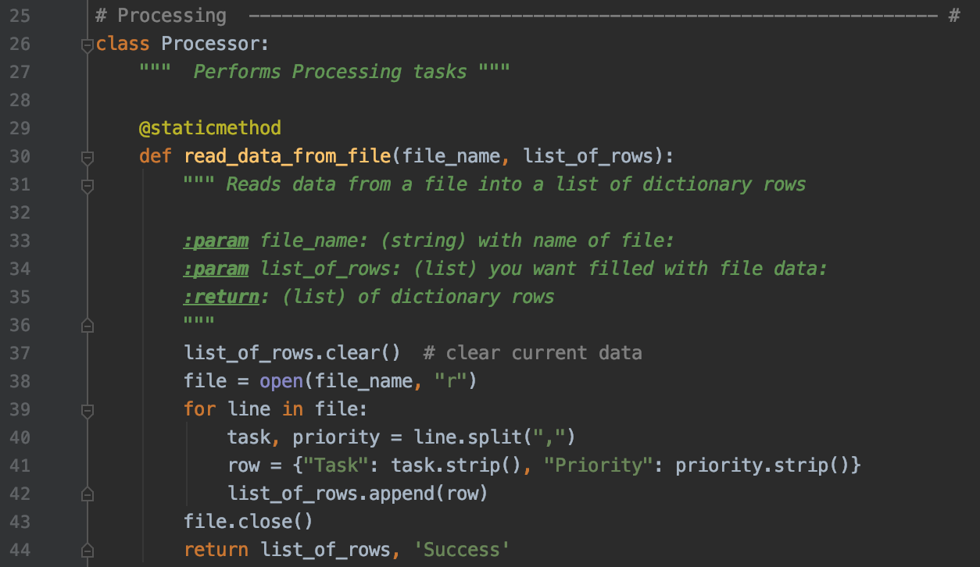

**Figure 1: Classes and Functions**

# **Learning the “Separation of Code” concept**

Learned how to convert a list from a text document when opening up the script to a dictionary. An example of the “Separation of Code” concept can be seen with the Processing and Presentation separations in both, **Figure 1: Classes and Functions** and **Figure 2: Presentation “Separation of Code”**.

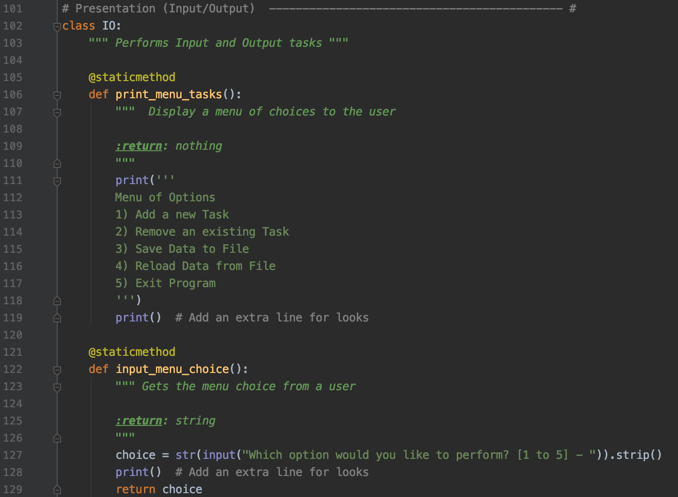

**Figure 2: Presentation “Separation of Code”**

# **Summary**

After learning everything with classes, functions, and the “Separation of Code” concept, I was able to create an interactive python script file that keeps the same core functionality as my last “To Do” list script while also having most of everything contained in its own functions. I’ve added a few screenshots below of it working in PyCharm, Terminal, and shows the output of the text document.

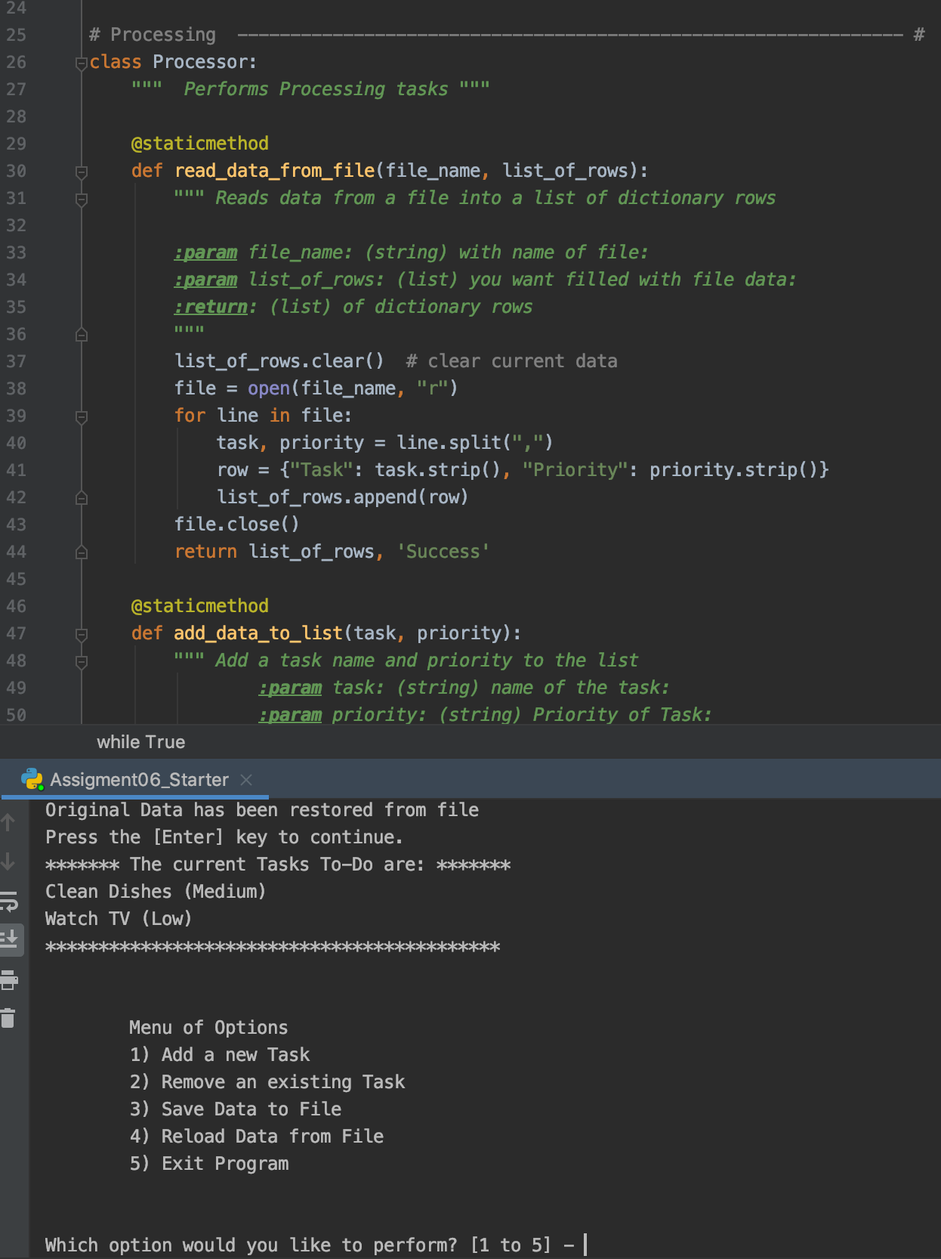

**Figure 5: Running in PyCharm**

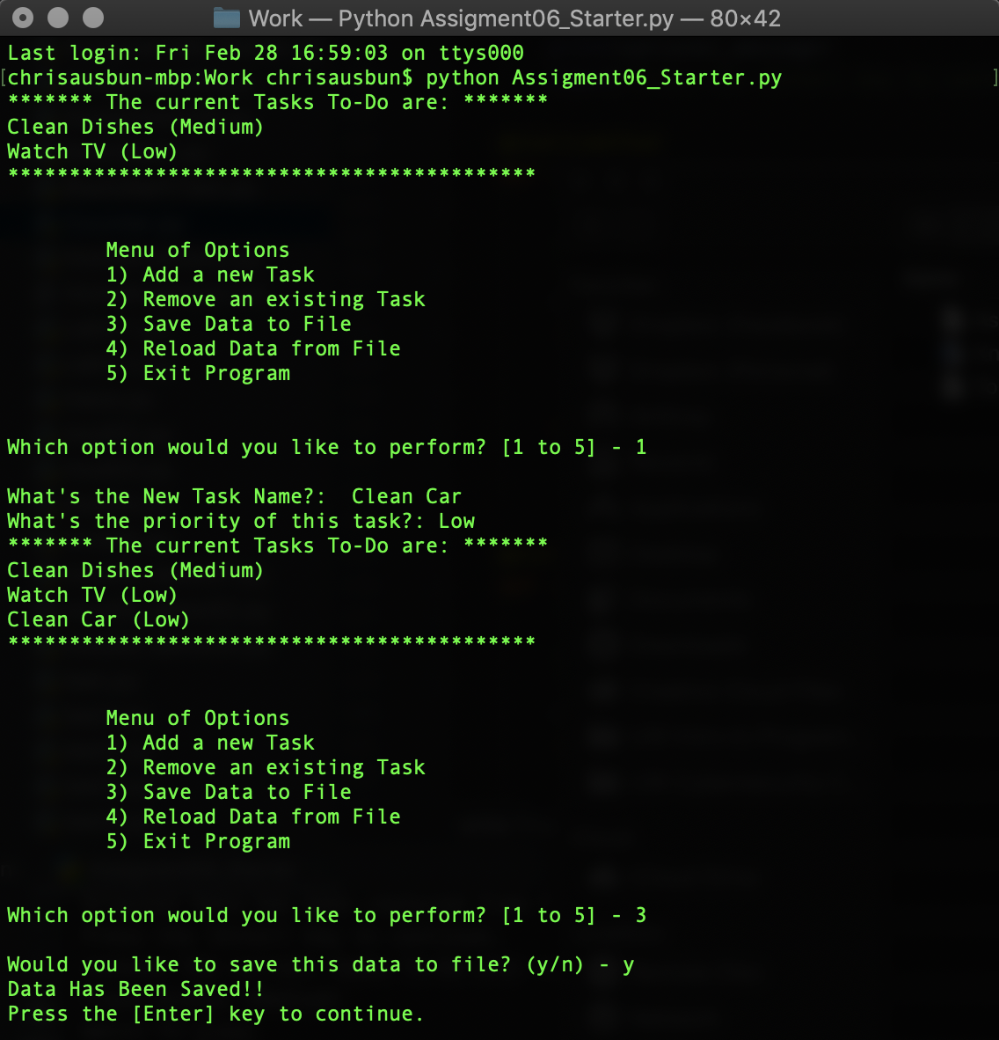

**Figure 6: Running in Terminal**

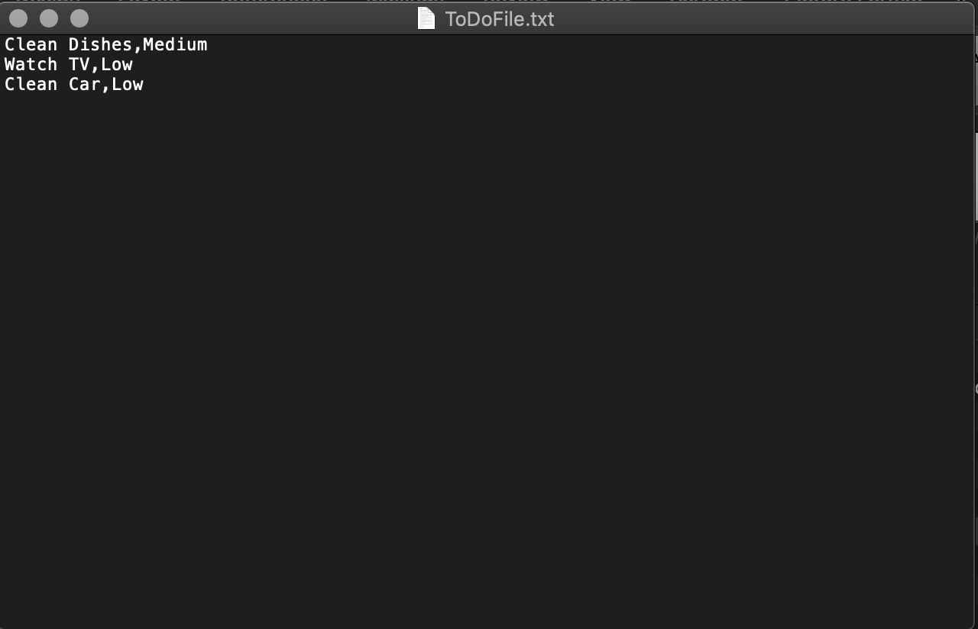

**Figure 7: Output .txt file**